* In Map Visual Perception, gradient colours are a better way to classify numerical data

1. In numerical data, such as population, economy, rainfall and other indicators, gradient colours will not provide more clarity and visual hierarchy
2. In numerical data, such as population, economy, rainfall and other indicators, gradient colours will provide more clarity and visual hierarchy

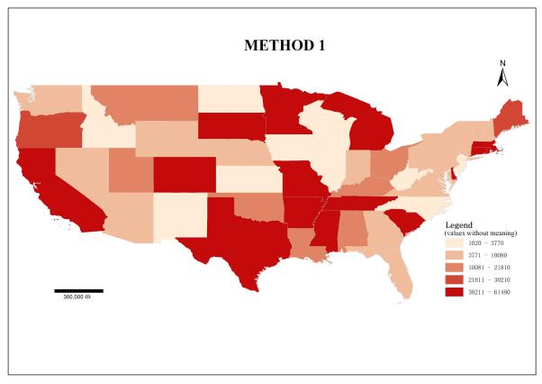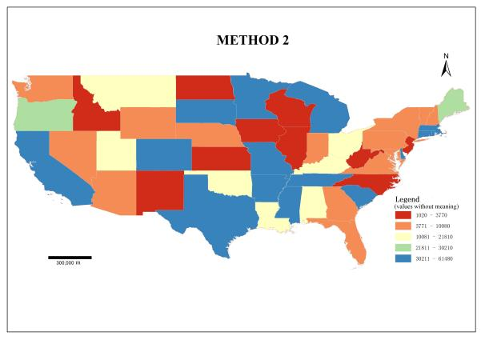

* In Map Visual Perception, categorical colours are a better way to classify categorical data

1. In categorical data, such as crop cultivation, eating habits, dialect systems and other categorical data, categorical colours will not provide more clarity and visual hierarchy
2. In categorical data, such as crop cultivation, eating habits, dialect systems and other categorical data, categorical colours will provide more clarity and visual hierarchy

